# Christmas Cheer Laser, part 10

Here is the API. The commands, except for gas, are easy GET statements given in the web page. The request we were given is a GET request, so we can cut and paste most of the API calls.

(Invoke-WebRequest -Uri http://localhost:1225/).RawContent

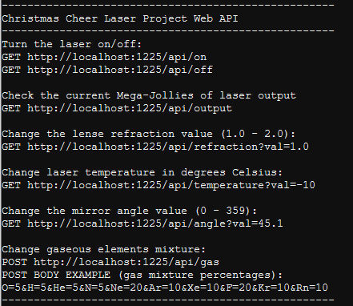

The values we’ve collected, at considerable effort, are:

angle?val=65.5

temperature?val=-33.5

$correct_gases_postbody = @{`n O=6`n H=7`n He=3`n N=4`n Ne=22`n Ar=11`n Xe=10`n F=20`n Kr=8`n Rn=9`n}

refraction?val=1.867

Since the gaseous elements use a POST request, there needs to be two extra parameters in the Invoke-Web request. We need -Method POST to say it is a POST request, and -Body to hold the data we want to POST.  
 -Body [contents of body]

It is easiest to put the body contents into a variable and then put -Body $Body into the request along with -Method POST. We are given two example formats for the body data. These values are in JSON format.  
$Body = @{O=6;H=7;He=3;N=4;Ne=22;Ar=11;Xe=10;F=20;Kr=8;Rn=9}  
The gases could also be written this way, still in JSON format. It is a PowerShell hash table, roughly equivalent to a Python dictionary.

$Body = @{

O=6

H=7

He=3

N=4

Ne=22

Ar=11

Xe=10

F=20

Kr=8

Rn=9

}

The example on the laser status page is in the text/application format.  
$Body = 'O=6&H=7&He=3&N=4&Ne=22&Ar=11&Xe=10&F=20&Kr=8&Rn=9' (correct values and quotes inserted)

Either of the three versions of $Body should work. I’ll use the last. I’ve also replaced RawContent with Content so the screen shot will be smaller.

(Invoke-WebRequest -Uri http://localhost:1225/api/off).Content

(Invoke-WebRequest -Uri http://localhost:1225/api/refraction?val=1.867).Content

(Invoke-WebRequest -Uri http://localhost:1225/api/temperature?val=-33.5).Content

(Invoke-WebRequest -Uri http://localhost:1225/api/angle?val=65.5).Content

$Body = 'O=6&H=7&He=3&N=4&Ne=22&Ar=11&Xe=10&F=20&Kr=8&Rn=9'

(Invoke-WebRequest -Uri http://localhost:1225/api/gas -Method POST -Body $Body).Content

(Invoke-WebRequest -Uri http://localhost:1225/api/on).Content

(Invoke-WebRequest -Uri http://localhost:1225/api/output).Content

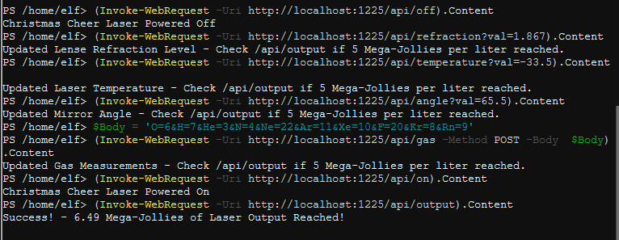

6.49 Mega-Jollies of Laser Output Reached! WooHoo! Note: The value you get is random, anything over 5 is good. Done at last.